**LAB 4**

**Gavin Monroe**

**9/20/17**

**PART 1:**

printf("Echoing output: %8.3lf, %7.4lf, %7.4lf, %7.4lf\n", (double)t / 1000, ax, ay, az);

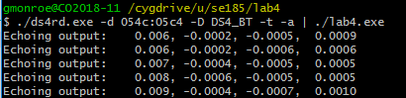

I converted the int to a double and divided how many milliseconds are in a second to get it to display in seconds instead in ms. I used the following process(%8.3lf) from classes and labs to display decimal places if present.

**PART 2:**

double mag(double x2, double y2, double z2);

double mag(double x2, double y2, double z2){

/* CODE SECTION 1 */

double sqrtX = pow(x2, 2);

double sqrtY = pow(y2, 2);

double sqrtZ = pow(z2, 2);

return sqrt(sqrtX + sqrtY + sqrtZ);

}

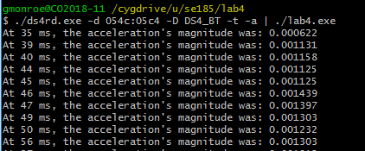

Looking at the code you most first do the required powers for each axis before you can square and add everything. You most also have the function Initialized before you can use it(above where ever you call it).

**PART 3:**

int minutes(int t){

t = (int) t / 1000;

t = (int) t / 60;

return (int) t;

}

int seconds(int t){

t = (int) t / 1000;

int mt = (int) t / 60;

if (t > 60){

t = (int) t - (mt * 60);

}

return (int) t;

}

int millis(int t){

int st = (int) t / 1000;

if (t > 1000){

t = (int) t - (st * 1000);

}

return t;

}

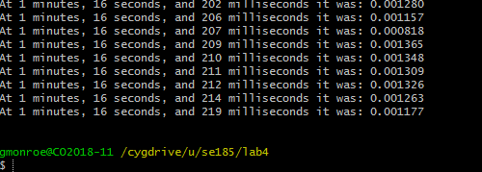

After Figuring out the rounding of the numbers, I then needed to calculate the change of seconds and milliseconds to make sure that it showed correctly You can see that in the IF statements in the actual functions.

**PART 4:**

int returnPressed(int a1, int a2, int a3, int a4){

if (a1 == 1){

counti += 1;

}

if (a2 == 1){

counti += 1;

}

if (a3 == 1){

counti += 1;

}

if (a4 == 1){

counti += 1;

}

printf("Being pressed:%d\n", counti);

counti = 0;

fflush(stdout);

}

Being pressed:1

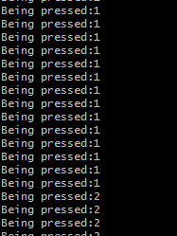

Have to see which one is pressed after and clear the pressed after presented.